Azure Confidential or Isolated Compute Design Study
Azure Services Utilization and Cost-Optimized Implementation
1. Project Objective
The project aims to study how sensitive workloads can be securely hosted on Microsoft Azure by comparing standard computing with specialized isolation technologies.
The project considers:
- Standard Virtual Machines as the baseline
- Azure Confidential VM for confidential computing
- Azure Dedicated Host for dedicated physical infrastructure
- Azure Virtual Network for network isolation
- Azure Key Vault for secure secret management
- Azure Monitor for monitoring and logging
- Managed Disks for VM storage
The implementation will prioritize free or low-cost Azure services, while specialized paid services will be evaluated conceptually or used only when Azure credits/institutional resources are available.

2. Proposed Cost-Optimized Azure Architecture
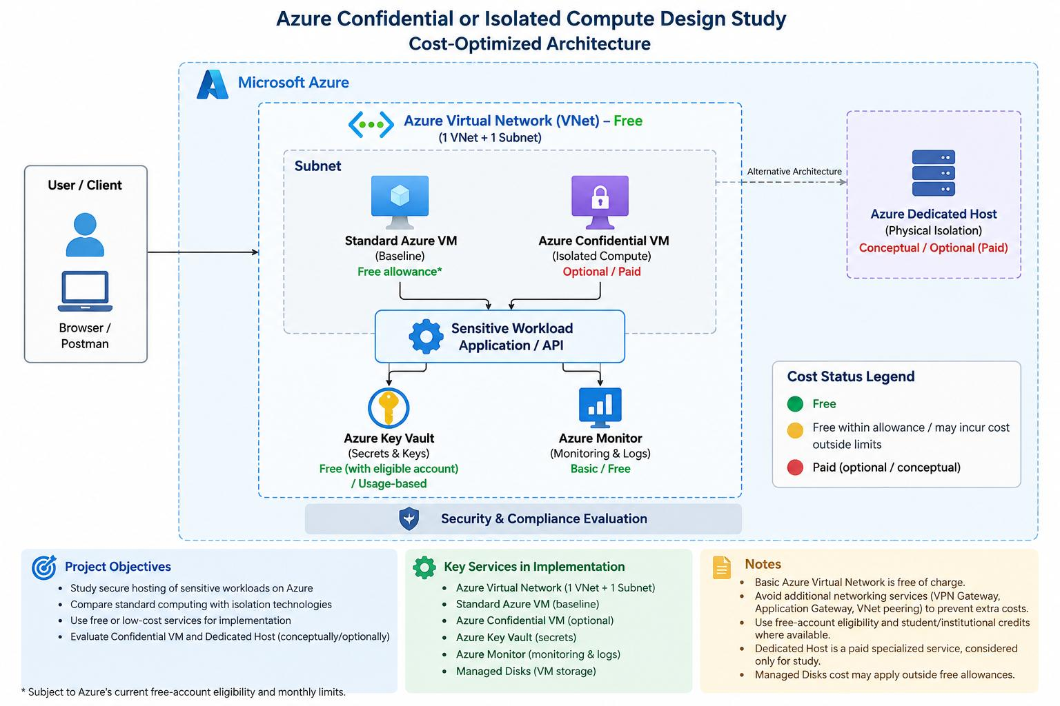
Dedicated Host is considered as an alternative architecture for physical isolation rather than a required deployment component because it is a paid specialized service.
*Subject to Azure's current free-account eligibility and monthly limits.

3. Azure Services and Cost Classification
Service | Purpose | Planned Usage | Cost Status
Azure Virtual Network | Network environment | 1 VNet + 1 subnet | 🟢 Free
Standard Azure VM | Baseline workload | 1 small VM | 🟢 Free allowance available for eligible accounts
Azure Confidential VM | Confidential workload comparison | Optional/short-term testing | 🔴 Paid
Azure Dedicated Host | Physical isolation comparison | Conceptual study / optional | 🔴 Paid
Azure Key Vault | Secrets and keys | 1 vault, limited secrets | 🟢 Free with eligible Azure free account / otherwise usage-based
Azure Monitor | Metrics and monitoring | Basic metrics/activity logs | 🟢 Basic monitoring largely free
Managed Disks | VM storage | Small OS disk | 🟡 Covered only within applicable VM/free-account allowance; otherwise paid
Azure currently lists the basic Virtual Network as free of charge. Additional networking services such as VPN Gateway or Application Gateway can incur charges, so they should be avoided for this student implementation unless required.

4. Azure Virtual Network
Purpose
Azure Virtual Network provides the basic private networking environment for the project.
Implementation
We will create:
- 1 Virtual Network
- 1 Subnet
The VM and other required resources will be placed within the network as appropriate.
Why we use it
It provides the networking foundation for the application and allows us to organize the compute environment securely.
Cost
FREE for the basic VNet.
Microsoft explicitly states that Azure Virtual Network is free of charge. Charges apply to additional services such as VPN Gateway, Application Gateway and VNet peering.
Project usage
Minimal — one VNet and one subnet.

5. Standard Azure Virtual Machine
Purpose
The Standard VM is our baseline environment.
It allows us to understand how a normal Azure VM handles the workload before comparing it with specialized compute.
Implementation
We can deploy one small Linux VM and use it for:
- Hosting a simple application/API
- Processing test requests
- Demonstrating workload execution
- Collecting basic performance metrics
- Establishing the baseline
Cost
Azure currently provides 750 hours/month for certain eligible burstable VM sizes for 12 months to qualifying new accounts.
Therefore:
Status: FREE within the applicable Azure free allowance.
If the selected VM size, disk, networking or usage exceeds the applicable free limits, charges can occur.
Cost-control method
We should:
- Select an eligible small VM size.
- Run it only when required.
- Stop/deallocate it after testing.
- Delete it when the project is complete.

6. Azure Confidential VM
Purpose
This is the main specialized technology being studied.
Confidential VM is designed to protect sensitive workloads while they are being processed using hardware-based confidential computing technologies.
Project usage
We use Confidential VM to study:
- Stronger workload isolation
- Protection of sensitive data during processing
- Security requirements
- Compliance considerations
- Performance differences
- Regional availability
- Cost implications
Important cost decision
We should NOT keep a Confidential VM running continuously just for the college project.
Instead:
Study → evaluate → deploy temporarily if Azure credits/subscription permit → collect observations → deallocate/delete.
Cost
PAID specialized compute.
It should not be presented in the report as a generally free service.
This directly addresses one of our project's bottlenecks:
Specialized compute provides additional security capabilities but introduces a cost premium and regional/SKU availability considerations.

7. Azure Dedicated Host
Purpose
Dedicated Host provides a physical server dedicated to our Azure workloads.
It represents another approach to infrastructure isolation.
Project usage
For our college project, we can study Dedicated Host as an alternative, comparing it with Confidential VM.
We don't need to deploy it unless the university provides the required Azure subscription/credits.
Cost
PAID.
Therefore:
Dedicated Host → architecture study / comparison rather than mandatory deployment.
This allows us to discuss the technology without creating unnecessary project expenditure.

8. Azure Key Vault
Purpose
Key Vault is used to securely manage:
- Passwords
- API keys
- Application secrets
- Certificates
- Cryptographic keys
Instead of putting secrets directly inside the application:
❌ Application Code
↓
Password
we use:
Application
↓
Azure Key Vault
↓
Secret / Key
Microsoft describes Key Vault as a service for safeguarding cryptographic keys and other secrets. Microsoft currently also advertises Key Vault as available with an Azure free account, subject to the free-account terms and applicable limits.
Project usage
We only need:
1 Key Vault + a small number of test secrets.
Cost
For the planned student-level usage:
🟢 FREE within applicable Azure free-account allowances.
Beyond applicable free usage/offer terms, Key Vault is usage-based and can incur charges.

9. Azure Monitor
Purpose
Azure Monitor is used to observe the health and performance of the workload.
We can monitor:
- CPU utilization
- VM metrics
- Activity logs
- Application activity
- System events
Project usage
We will keep monitoring simple.
VM
↓
Azure Monitor
↓
Metrics + Activity Logs
↓
Performance Analysis
Cost
Basic monitoring is largely FREE.
Microsoft states that standard platform metrics and automatically enabled activity logs are provided at no cost. Additional log ingestion, retention and some monitoring capabilities can incur charges.
Project approach
We will use:
Basic metrics + activity logs
and avoid unnecessary high-volume Log Analytics ingestion.
Therefore:
🟢 FREE for our basic planned usage.

10. Managed Disks
Purpose
The VM requires storage for its operating system and application.
VM
│
└── OS Disk
Project usage
We will use the smallest appropriate disk configuration for the demonstration.
Cost
Managed disks are normally billable storage resources. However, the applicable free VM offer includes specific storage allowances/conditions, so the exact disk configuration must be checked against the current free-account offer before deployment.
Therefore, in the report, the safest classification is:
🟡 Free only within applicable free-account allowance; otherwise Paid.
We should avoid adding unnecessary data disks.

11. Free vs Paid Implementation Strategy
For our actual student implementation, the plan should be:
🟢 FREE / LOW-COST CORE
1. Azure Virtual Network
Free.
2. Small eligible Standard VM
Use within the Azure free allowance.
3. Azure Key Vault
Use the free-account allowance and keep usage minimal.
4. Azure Monitor
Use free platform metrics and activity logs.
🔴 SPECIALIZED / PAID — STUDY OR TEMPORARY USE
5. Confidential VM
Deploy only if required and if Azure credits/institutional subscription are available.
6. Dedicated Host
Study as an alternative; don't deploy unless funding/credits are provided.
This approach is much more sensible for a college project, because the project can demonstrate the architecture and evaluation without unnecessarily spending money.

12. Complete Project Flow
Phase 1 — Network Setup
Azure Portal
↓
Resource Group
↓
Virtual Network
↓
Subnet
Phase 2 — Baseline Deployment
Standard VM
↓
Application / API
↓
Sensitive Workload
Phase 3 — Security
Application
↓
Azure Key Vault
↓
Secrets / Keys
Phase 4 — Monitoring
VM + Application
↓
Azure Monitor
↓
Metrics + Activity Logs
Phase 5 — Specialized Compute Study
Standard VM
│
│ Compare
▼
Confidential VM
│
▼
Security / Isolation / Performance
Phase 6 — Architecture Evaluation
We compare:
Security + Isolation + Compliance + Performance + Availability + Cost

13. Recommended Project Scope
For your actual college implementation, I would document the scope like this:
The project will primarily use Azure services available through free tiers, free allowances, or institutional Azure credits. A Standard Azure VM will serve as the baseline compute environment, while Azure Virtual Network, Key Vault and basic Azure Monitor capabilities will provide networking, secret management and monitoring. Confidential VM and Dedicated Host will be evaluated as specialized compute alternatives. Where these specialized services require paid resources or specific hardware availability, they will be treated as evaluation/deployment options subject to available Azure credits and regional support.
This is a much better approach than saying “we are going to deploy everything” because your project itself identifies cost premium as a bottleneck.

14. Final Cost-Oriented Service Table
Service | Required? | Free/Paid | Our Approach
Azure Resource Group | Yes | Free | Use
Azure VNet | Yes | Free | Use
Standard VM | Yes | Free within eligible allowance | Use small eligible VM
Confidential VM | For specialized evaluation | Paid | Optional/temporary
Dedicated Host | Alternative | Paid | Study only unless credits available
Key Vault | Yes | Free within applicable free-account allowance; otherwise usage-based | Minimal usage
Azure Monitor | Yes | Basic metrics/logs free; extra usage paid | Basic monitoring only
Managed Disk | Yes with VM | Free allowance/otherwise paid | Smallest suitable disk
VPN Gateway | No | Paid | Do not use
Application Gateway | No | Paid | Do not use
Azure Firewall | No | Paid | Do not use
Microsoft Sentinel | No | Paid | Do not use
Azure explicitly provides free services/allowances, including a category of services that are always free and others that are free for 12 months for eligible new accounts.

